NAME: K NAVYA
REG : 192371022
CLASS ACTIVITY
- Arithmetic Exception – Student Calculator

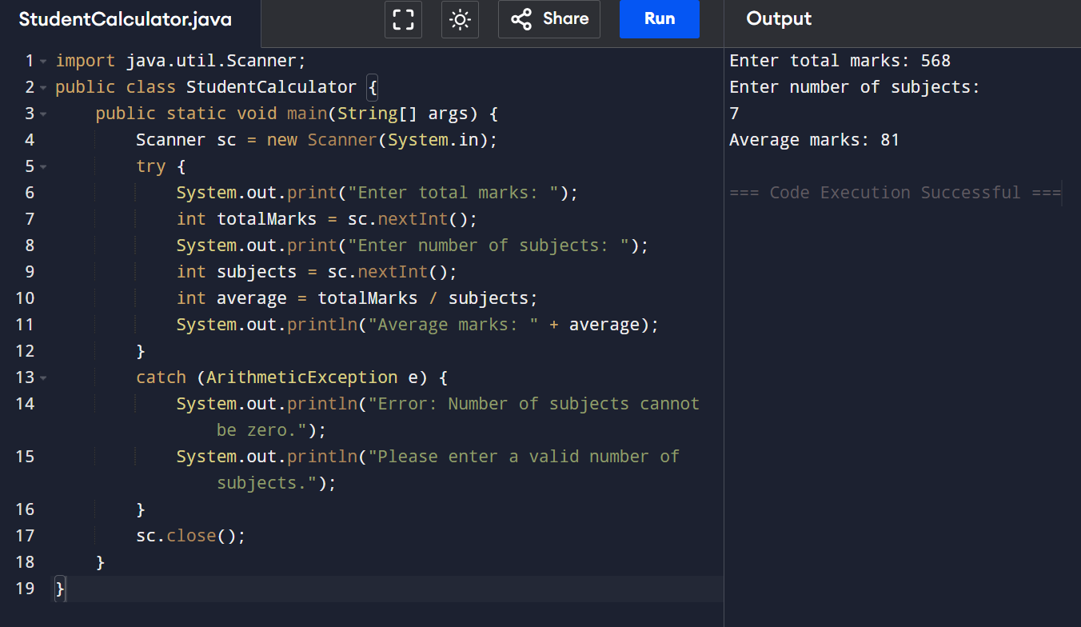

- Null Pointer Exception – Employee Management System

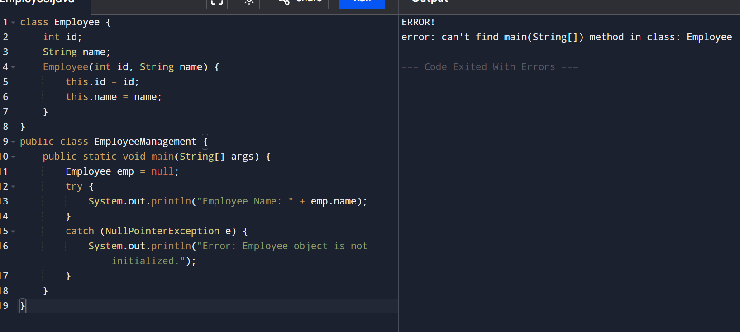
- Array Index Out Of Bounds Exception – Student Marks Processing

- 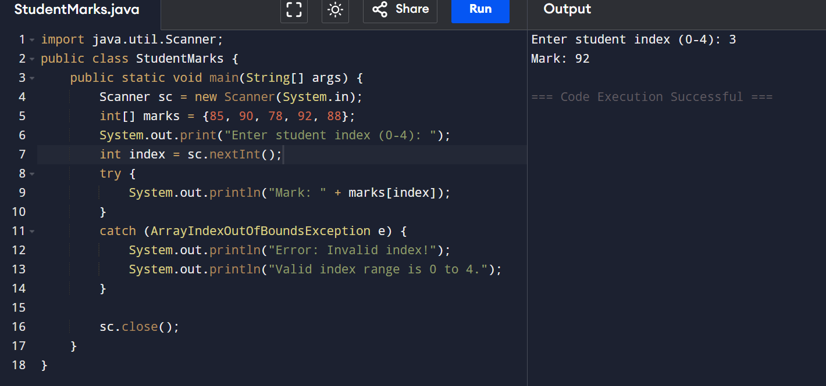

- Number Format Exception – Customer Registration System

